GET DIRTY
With Perth’s local gardening expert and designer
SABRINA HAHN
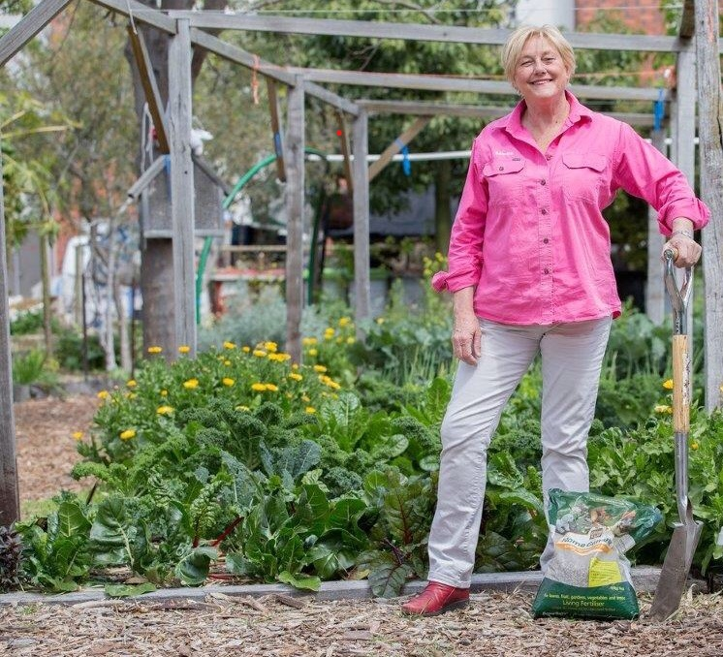
FRIDAY 26 MARCH 2021 – GATES OPEN AT 10 AM
QUEST SPEAKER SABRINA HAHN AT 11 AM SHARP
59 ESTUARY VIEW ROAD, DAWESVILLE
LIMITED TICKETS AVAILABLE $40 EACH – NO DOOR SALES
RSVP ELIZABETH GORMAN ON 0484379655/ EJGORMAN1@GMAIL.COM
BY 11 MARCH 2021
WINE TASTING AND SALES BY DRAKESBROOK WINES
LOCAL ARTISTS DISPLAYING WORK (IN ALPHABETICAL ORDER)
ROBBIE HEARSE, JEN SADLER, BARBARA THOMS, JENNI WALDRON, BETTY WALSH, CINDY WRIGHT
RAFFLES, SUPPORTING FIRE VICTIMS AND MAY DAY OP SHOP - MORNING TEA
PROUDLY SUPPORTED BY DIRT’ N’ BOONDIES, MUSICAL KITE STRING, HALO UNISEX SALON, PRAIRIE CAFÉ, DRAKESBROOK WINES, SUZI ROWLEY DESIGNS,THE SHACK 59 AND GRUMPYGROOTZ UNIQUE WOOD DESIGNS
